Manylion yr Eiddo / Details of the Property
Gwybodaeth I’w anfon 6 mis cyn yr eiddo fod yn barod /
Information to be sent 6 months before the property is ready
Plis noder y wybodaeth isod neu amgau’r ddogfen perthnasol

Please note relevant information below or attach documents
Cyfeiriad y Datblygiad(gan gynnwys cod post)  Address of property (inc post code) | Plot 84 -  24 Ffordd Porthdy, Rhuddlan, LL18 6HZ  (Datblygwyr MacBryde Developers – House Type/ Math Eiddo – Oakley)  Ar gael – Rhagfyr 2020  Available – December 2020
Lluniau o’r eiddo  Pictures of the property | 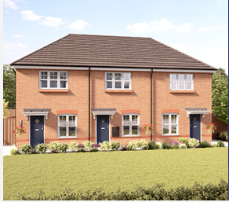  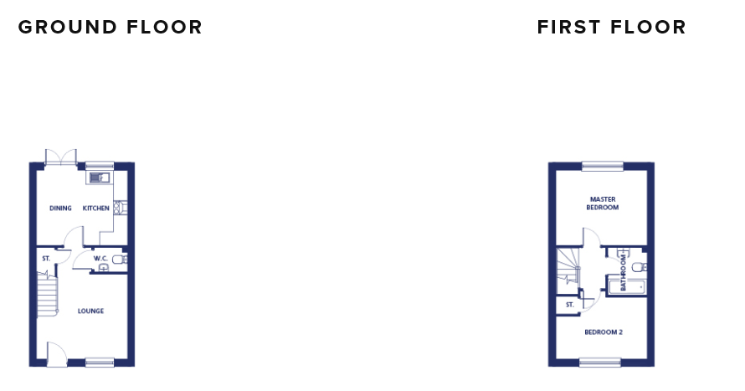
Ty ar ben ei hun / Detached  Tŷ pâr / semi detached  Tŷ terras / terraced  Fflat / apartment | Tŷ pâr / semi detached
Nifer o loftydd & person  No of beds & person  (e.g.3b5p) | 2 Llofft – 4 person / 2 bedroom 4 person
Deiliadaeth / tenure:- | Rhentu I Brynu / Rent to Own
Disgrifiad byr o’r eiddo – i’w newid ar gyfer pob eiddo. esiampl  Brief description of property – please amend accordingly | Mae'r cartref hyfryd 2 ystafell wely hwn yn ddelfrydol ar gyfer prynwyr tro cyntaf. Mae ardal agored ar draws y llawr gwaelod yn creu digon o le. Mae drysau Ffrengig yn agor allan i'r ardd yn y cefn. Mae dwy ystafell wely fawr wedi'u lleoli ar y llawr cyntaf ochr yn ochr ag ystafell ymolchi deuluol o ansawdd uchel.  This delightful 2-bedroom home is ideal for first-time buyers or downsizers. An open-plan layout across the ground floor creates a sense of space, and French doors open out onto the garden at the rear, truly bringing the outside in. Two spacious bedrooms are located on the first floor alongside a sleek family bathroom with high quality sanitary ware from a renowned European designer.  Mae’r cartref yn cynnwys:  - Gwres canolog LPG / LPG central heating,  - Ffenestri a drysau gwydr dwbl UPVC / UPVC double glazed windows and doors  - Gerddi yn y tu blaen a’r cefn / Gardens to the front and rear,  - Ardal ar gyfer parcio oddi ar y ffordd / Drive way for off road parking.  Ystafell fyw / Living Room: 3.93m x 3.67m  Cegin / Ystafel fwyta / Kitchen / Dinning Room: 3.93m x 3.67m  - LPG oven & hob  - Cooker hood  - Integrated Dishwasher  - Integrated Fridge / Freezer  Lloft 1 / Bedroom 1: 2.08m x 1.70m  Lloft 2 / Bedroom 2: 3.93m x 2.67m  Ystafell Ymolchi / Bathroom: 2.08m x 1.70m  Allan / External:  Gweler atodiad 1 - See attachment 1
Plis noder Isafswn Incwm Cartref dylid eu hystyried / please note the minimum household income to be considered | Rhentu I brynu yn unig / Rent to own only  £29,175
Pris Farchnad agored /  Open market price | Rhentu I brynu yn unig / Rent to own only  £156,000
Rhent misol  Monthly rent | £675 y mis / monthly
Tal Gwasanaeth  Service Charges | £15.10 y mîs yn ychwanegol I rhent misol / in addition to monthly rent
Ar gael  Available from | Rhagfyr 2020  December 2020
Blaendal  Deposit | Bydd rhent mis a mis blaen dal angen ei dalu ar dechrau’r denantiaeth. Blaendal = £675  One month’s rent and one month’s deposit will be required at start of tenancy. Deposit = £675  Bydd y blaendal yn cael ei gadw o dan delerau’r Deposit Protection Service (DPS).  The ‘Deposit Scheme’ protecting your deposit with Adra is – The Deposit Protection Service (DPS)
Tenantiaeth  Tenancy | Mae’r denantiaeth yn Denantiaeth Aswiriedig Byrddaliol 6 mis,fydd wedyn yn parhau ar sail misol. Cyn belled â gedwir at dermau’r denantiaeth, mae ein hymrwymiad i chi yn un tymor hir.  The tenancy is a 6 month Assured Shorthold Tenancy, which will thereafter continue on a month by month basis. Provided you keep to the terms of the tenancy, our commitment to you is a long- term commitment
Meini Prawf Preswylio  Residency Criteria | Blaenoriaeth i ymgeiswyr sy’n byw neu weithio yn ardal Sir Ddinbych.  Os nad oes ymgeiswyr addas yn cyrraedd y meini prawf cysylltiad lleol byddwn yn ystyried pob ymgeisydd cymwys arrall.  Priority given to applicants who live or work in the Denbighshire County area.  If no applicant meets Adra’s local connection criteria all other eligible applicants will be considered.
Copi o’r Amod 106 /  Copy of the Section 106  (os yn berthnasol / If relevant) | Not applicable
Tystysgrifau Perfformiad Ynni  Energy Performance Certificate | B – wedi atodi / attached - Attachment 2
Band Treth y Cyngor
Council Tax Band

Yda chi’n caniatau anifieilad anwes ?  Would you allow pets? | Yndan – ond yn unol a’r cytundeb tenantiaeth a unrhyw gyfyngiadau ar y safle .  Yes – but in accordance with the tenancy agreement and any site restrictions
Unrhyw gyfyngiadau eraill ar y datblygiad h.y. dim cerbydau gwaith campervan ayb  .  Any other restrictions on the development i.e no campervan/now work vehicles etc. | Bydd pob eiddo yn destun cyfamodau a osodir gan y Datblygwr, gan gynnwys (ond heb fod yn gyfyngedig i) y canlynol:  - Rhwymedigaethau mewn perthynas â Waliau Cydrannol a ffensys  - Cyfyngiadau ar barcio  - Cyfyngiadau Defnydd a Galwedigaeth  - Cyfyngiadau a rhwymedigaethau sy'n ymwneud â Gerddi Blaen a Chefn  - Cyfyngiadau ar addasiadau a gwaith adeiladu  - Rhwymedigaethau'n ymwneud â chynnal a thirlunio Coed, Llwyni ac ymylon  - Rhwymedigaethau'n ymwneud â Charthffosydd a Gwasanaethau Eraill, (gan gynnwys cydsynio i Hawddfreintiau)  - Cyfyngiadau ar osod Arwyddion  - Cyfyngiadau ar gadw a bridio Anifeiliaid  - Rhwymedigaethau mewn perthynas â Thâl Gwasanaeth  - Unrhyw rwymedigaethau neu gyfyngiadau ychwanegol eraill fel y'u gosodir gan y Datblygwr.  Nodwch os gwelwch yn dda: Nid yw'r rhestr uchod yn derfynol ac mae'n destun newid.  Bydd copi papur yn rhestru'r Cyfamodau perthnasol ar gael wrth arwyddo, ond gellir darparu copïau cyn hyn ar gais.  All properties will be subject to covenants imposed by the Developer, including (but not limited to) the following:  - Obligations in relation to Party Walls and fences  - Restrictions on parking  - Restrictions of Use and Occupation  - Restrictions and obligations relating to Front and Back Gardens  - Restrictions on alterations and Building work  - Obligations relating to maintenance and Landscaping of Trees, Shrubs and verges  - Obligations relating to Sewers and Other Services, (including consenting to Easements)  - Restrictions on installing Signage  - Restrictions on the keeping and breeding of Animals  - Obligations in relation to Service Charges  - Any other additional obligations or restrictions as imposed by the Developer.  Please note: The above list is not definitive and is subject to change.  A paper copy listing the relevant Covenants will be available on sign-up, however copies can be provided prior to this on request.  Attachment 3 - Restrictions
Plis noder dyddiad yr hoffech gychwyn marchanat / Please note the date you would like to start marketing | 30/06/2020 - cyn gynted â phosib plis / as soon as possible
Plis noder dyddiad yr hoffech yr eiddo gau ar y wefan / Please note the date you would like the property to close on the web-site | 01/10/2020
Enw / Name | Tamany Clwyd-Jones
Llofnod / Signature | TCJ
Dyddiad / Date | 23.06.2020

- Esiampl o ddisgrifiad eiddo / Example of property description
Mae’r eiddo’n cynnwys lolfa, cegin/ystafell fwyta, ystafell gotiau lawr grisiau, * llofft, en-suite ac ymolchfa. / The property briefly comprises living room, kitchen/diner, downstairs cloakroom, * bedrooms, en-suite and family bathroom.
Gwres canolog nwy / Gas central heating,
Gwres canolog trydan / Electric central heating
Gwres canolog olew / Oil central heating
Ffenestri a drysau gwydr dwbl UPVC / UPVC double glazed windows and doors
Mae’r eiddo yn cynnwys carped/gorchudd llawr ymhob ystafell / This property is offered with carpets and flooring throughout.
Gerddi yn y tu blaen a’r cefn / Gardens to the front and rear,
Ardal ar gyfer parcio oddi ar y ffordd / Drive way for off road parking
Ardal parcio wedi ei neilltuo / Allocated parking
Mae’r eiddo’n cynnwys ystafell fyw, cegin/ystafell fwyta, ystafell gotiau lawr grisiau, * llofft, en-suite ac ymolchfa. / The property briefly comprises living room, kitchen/diner, downstairs cloakroom, * bedrooms, en-suite and family bathroom.

Cyntedd / Hallway: (Manylion / description)

Ystafell Fyw / Living Room : (Manylion / description)

Cegin / ystafell Fwyta / Kitchen/dining room :(Manylion / description)

Ystafell gotiau / Cloakroom (Manylion / description)

Llofft 1 / Bedroom 1: (double / single front, rear) (Manylion / description)

Llofft 2 / Bedroom 2: (double / single front, rear) (Manylion / description)

Llofft 3 / Bedroom 3: (double / single front, rear) (Manylion / description)

Ymolchfa / Bathroom ; (Manylion / description)

Tu allan / External (Manylion / description)

