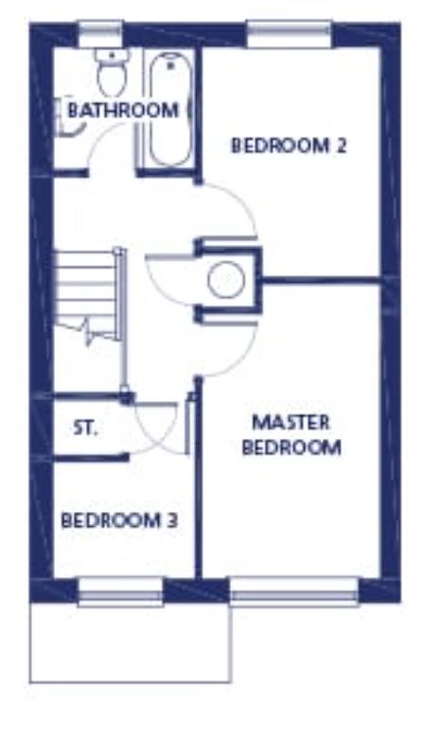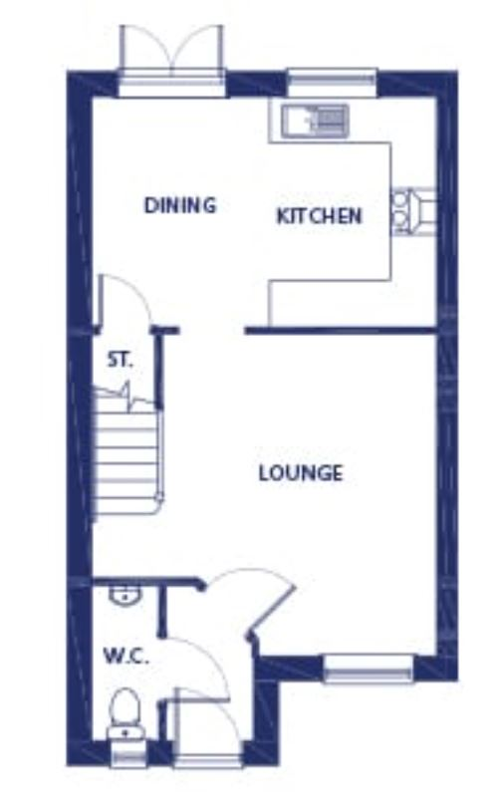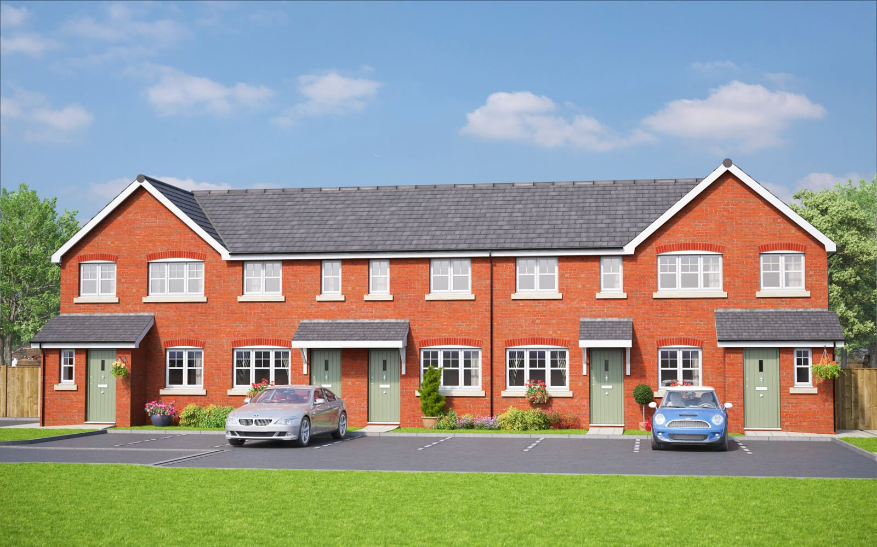

**DISGRIFIAD**

Mae’r cartref tair ystafell wely wedi’i leoli ar safle datblygiad dymunol Bron y Castell yn Abergele. Mae’r cartref teuluol hwn yn cynnwys prif ystafell wely eang, dwy ystafell wely arall ac ystafell ymolchi i rannu. Mae’r ystafell fyw yng nghartref Highfield ar flaen y tŷ, yn ogystal â thŷ bach i lawr y grisiau. Mae’r ystafell fyw yna’n arwain at gegin ac ardal fwyta cynllun agored, sy’n agor allan i’r ardd drwy’r drysau patio.

**CYFLEUSTERAU A NODWEDDION**

*3 ystafell wely*

*Cegin fodern*

*Tŷ bach i lawr y grisiau*

*Ffenestri Gwydr Dwbl*

*Gwres Canolog Nwy*

*Carpedu/lloriau – finyl gwrthlithro yn y gegin a’r ystafelloedd ymolchi a charped ymhob ystafell arall*

**DESCRIPTION**

This 3-bedroom home is situated in the highly desirable Bron Y Castell development in Abergele. This family home is finished upstairs with a well-sized master bedroom, two additional bedrooms and a shared bathroom.The lounge of the Highfield home is at the front of the house, as is the downstairs WC. The lounge then leads to the open plan kitchen and dining area, which opens up into the garden through the patio doors.

**FACILITIES & FEATURES**

*3 bedrooms*

*Modern fitted kitchen*

*Downstairs WC*

*Double glazed*

*Gas central heating*

*Carpeting/flooring – non slip vinyl to kitchen and bathrooms and carpet in all other rooms*

*Argraff artistig (efallai bydd rhai gorffeniadau yn amrywio unwaith y bydd wedi’i adeiladu)*

*Artist impression (some finishes may differ once built)*

£540 PCM

**THE HIGHFIELD**  3 LOFFT / BEDROOM, Bron Y Castell, Abergele **£540 Y MIS CALENDR/ PCM**