£150,000 O.I.E.O
2 bed mews house
Heathland Close, Buckley
Redrow development, with 5 years NHBC remaining.
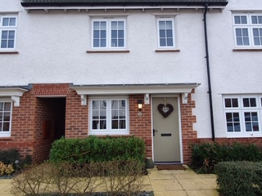

Key Features
- Two double bedrooms with fitted wardrobes, one with en-suite
- Immaculate condition
- Large bright comfortable lounge
- South Facing Artificially turfed garden with patio
- Two car parking spaces
- Semi boarded loft space with ladder access
- Modern bathroom
- Separate laundry and cloakroom
- Offered with flooring and carpets throughout property
- Tax Band – C
- Gas central heating
- Double glazed windows and doors

Lounge – 4.08m x 3.86m
A pleasant bright room aided by the natural light coming through the double French doors that lead to the patio area and garden. The dimensions offered are more than adequate to provide a comfortable living space, whilst accommodating space for a dining table and chairs without the feeling of being overcrowded.
Garden
Stepping outside the lounge and into the garden, we find an area enclosed by quality wooden fence panels. Alongside the fence line you will find well established borders flush with flowers. At the bottom of the garden a large wooden shed provides for all your garden equipment storage requirements. The patio area is still large enough to provide space for a table and four chairs, BBQ and bin storage. The property also provides an outside tap and power points. The standout feature is the artificial turf that provides all year-round greenery.

Kitchen - 2.88m x 1.89m
Although compact, the kitchen space provides space for an integrated dishwasher, oven with gas hob, plus space for fridge freezer. A large larder cupboard provides plenty of storage. Off the kitchen is a cloakroom with additional storage spac
Hallway
Wood tile effect flooring continues from the kitchen through the hall where you will find a downstairs W.C to the left and a laundry cupboard to the right.

Master Bedroom – with en-suite – 3.34m x 2.69m plus (en-suite 2.73m x 1.09m)
The master bedroom comfortably fits a double bed, with two bed side drawers. Storage space comes from the large fitted sliding double wardrobe. Off from the bedroom is an en-suite with WC, basin and shower.

Bedroom 2 – 3.86m x 2.50m
Bedroom 2 is currently setup as a nursery but has previously been used as a comfortable double bedroom. This room also includes fitted wardrobes. The room also benefits from two aspect windows offering plenty of natural light.
Bathroom
The bathroom provides large bath with shower overhead. Finished with a built in WC and basin in a beautiful finish with marble top surface.

