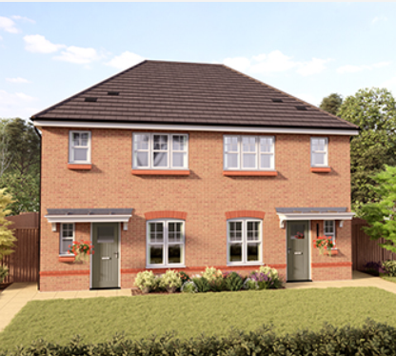

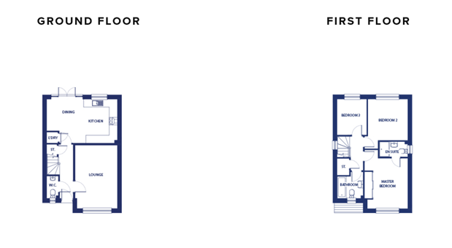

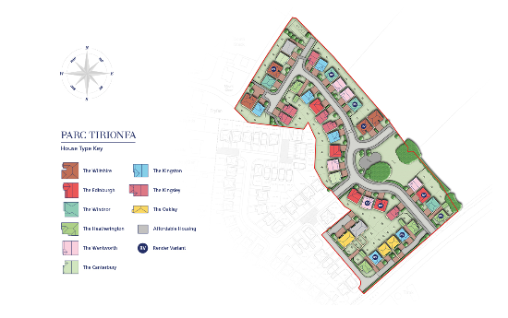

INTERNAL FEATURES
•Internal walls painted Almond White
•Internal white panelled doors with chrome effect door furniture
•Smooth skimmed ceilings
•White gloss internal mouldings
•Staircase to be painted white with contrasting handrail
•Wardrobes fitted to master bedroom in detached properties (see working drawings)
•Wiring for satellite TV (Sky compatible)
•TV point to lounge, master bedroom and family room (where applicable)
•White electrical sockets and pendant light fittings
•Fused spur for provision of electric fire (4-bedroom properties only)
•USB sockets (kitchen and master bedroom only)

EXTERIOR FEATURES
•Sealed double glazed white PVC-U windows,
with French windows fitted
•Front door – GRP pre finished door in a solid
colour externally and white internally
•Rear door – GRP door finished in white
•External light to front entrance
•Steel up and over garage door painted to match front door (where applicable)
•Patio and pathways to be concrete paving flags (as per working drawing)
•1.8m timber close boarded fence to side and rear
•Turf and landscaping to front garden (refer to landscape layout)
•Rear garden to be top soil
•Driveways to be block paved
•All shared drives and parking courts to be tarmac
KITCHEN & UTILITY FEATURES
•Choice of kitchens from Panorama Kitchens
•Choice of co-ordinating laminate worktops
•Choice of Johnson’s ceramic floor tiles to kitchen and breakfast area
•Ceiling downlighters to kitchen area

APPLIANCES
•600mm gas hob with recirculating extractor hood and single oven fitted to 2 & 3-bed properties
•750mm gas hob with 900mm extractor hood, double oven fitted to 4-bed detached properties only
•Integrated fridge freezer
•Integrated dishwasher to 4-bed detached
properties only
BATHROOM, EN-SUITE & CLOAKROOM
•Ideal Standard Tempo range in white
Shower to en-suite (where applicable)
•Shower valve to be Aqualisa Dream
•Low level shower tray with concealed waste
•Shower screen to enclosure
•Shower over bath (except in bathrooms with
both shower cubicle and bath)
•Choice of co-ordinating wall tiles (see working drawings)
•Downlighters fitted to master en-suite
•Chrome heated towel rail fitted to bathroom
and en-suite

ENERGY SAVING FEATURES
•Energy efficient gas central heating, zone
controlled and weather compensated
•100% low energy light fittings throughout
•Insulated brick/block cavity construction
•400mm (min) thick roof insulation

