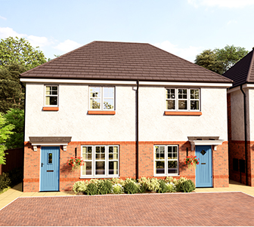

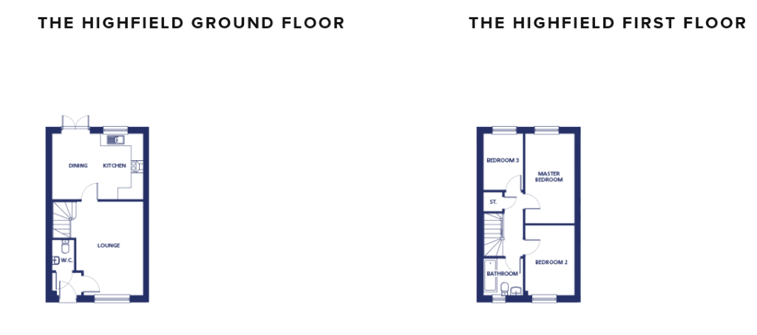
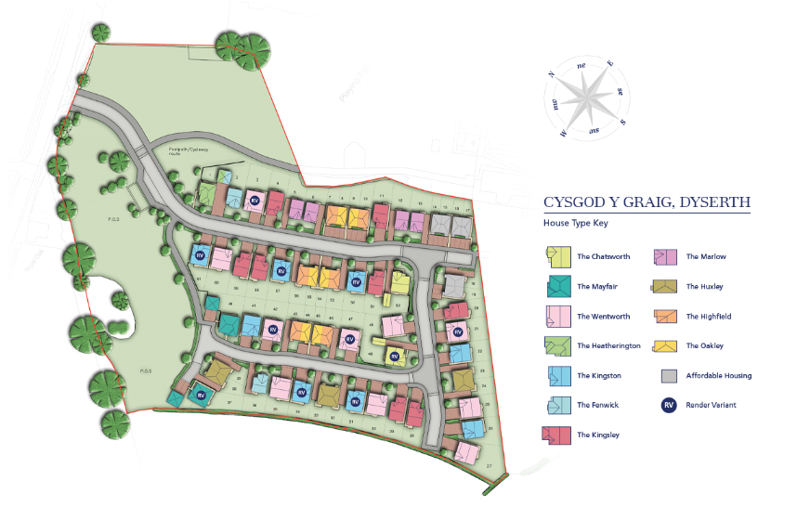

INTERNAL FEATURES
- Internal walls painted Almond White
- Internal white panelled doors with chrome effect door furniture
- Smooth skimmed ceilings
- White gloss internal mouldings
- Staircase to be painted white with contrasting handrail
- Wardrobes fitted to master bedroom in detached properties (see working drawings)
- Wiring for satellite TV (Sky compatible)
- TV point to lounge, master bedroom and family room (where applicable)
- White electrical sockets and pendant light fittings
- Fused spur for provision of electric fire (4-bedroom properties only)
- USB sockets (kitchen and master bedroom only)
EXTERIOR FEATURES
- Sealed double glazed white PVC-U windows,
with French windows fitted
- Front door – GRP pre finished door in a solid
colour externally and white internally
- Rear door – GRP door finished in white
- External light to front entrance
- Steel up and over garage door painted to match front door (where applicable)
- Patio and pathways to be concrete paving flags (as per working drawing)
- 1.8m timber close boarded fence to side and rear
- Turf and landscaping to front garden (refer to landscape layout)
- Rear garden to be top soil
- Driveways to be block paved
- All shared drives and parking courts to be tarmac
KITCHEN & UTILITY FEATURES
- Choice of kitchens from Panorama Kitchens
- Choice of co-ordinating laminate worktops
- Choice of Johnson’s ceramic floor tiles to kitchen and breakfast area
- Ceiling downlighters to kitchen area
APPLIANCES
- 600mm gas hob with recirculating extractor hood and single oven fitted to 2 & 3-bed properties
- 750mm gas hob with 900mm extractor hood, double oven fitted to 4-bed detached properties only
- Integrated fridge freezer
- Integrated dishwasher to 4-bed detached
properties only
BATHROOM, EN-SUITE & CLOAKROOM
- Ideal Standard Tempo range in white
Shower to en-suite (where applicable)
- Shower valve to be Aqualisa Dream
- Low level shower tray with concealed waste
- Shower screen to enclosure
- Shower over bath (except in bathrooms with
both shower cubicle and bath)
- Choice of co-ordinating wall tiles (see working drawings)
- Downlighters fitted to master en-suite
- Chrome heated towel rail fitted to bathroom
and en-suite
ENERGY SAVING FEATURES
- Energy efficient gas central heating, zone
controlled and weather compensated
- 100% low energy light fittings throughout
- Insulated brick/block cavity construction
- 400mm (min) thick roof insulation

