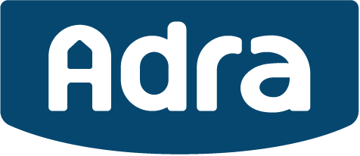

ALLOCATION CRITERIA – Dôl Rhedyn and Maes y Rhedyn

In order to qualify to purchase or rent an Adra property at Dôl Rhedyn and Maes y Rhedyn, Llay developments you must meet the following criteria:

- Registered on the Affordable Housing Register or the Council’s Waiting List

- Eligible applicants will be considered in the following order of priority:

Priority 1 -
- Residing / or close family – Llay Community Council area – one year preceding occupation or in full time employment within Llay Community Council area for a period of 6 months preceding proposed occupation
- previous residency/ or close family -– Llay Community Council area – continuous period 5 years or previous employment within Llay Community Council area for a period of 5 years

Priority 2 -
– as above – but for – Gwersyllt, Rosset and Gresford Community Council Areas. (to include further marketing etc)

Priority 3 -
– if no Priority 1 or Priority 2 – after 8 weeks – open out to Wrexham County Borough Council Area.

Priority 4 -
– if no applicant qualifies in Priority 3 within 12 weeks – then any other person who is in the opinion of Adra or Council is a person in Housing Need shall be treated as an Eligible Person.

In addition to the above, applicants must meet general Shared Ownership and Intermediate Rent eligibility criteria, full details of which can be found on the Tai Teg website www.TaiTeg.org.uk and Adra will prioritise eligible applicants in date order of registration :

Applicants for shared ownership must be:
- First time buyers
- Be a newly forming household
- Be unable to afford to buy a property suitable for their family size on the open market
- Not have a household income of more than £60,000 per annum
- Must be working and not eligible for the Housing Element of Universal Credit or Housing Benefit
- Not own another property
Applicants for Intermediate Rent must be:
- Age – be at least 18 years old
- be in housing need due to one or more of the following:
✓ current accommodation being unaffordable
✓ no security of tenure
✓ accommodation not suitable for the household’s need
✓ need to be closer to family or employment
- have a gross household income between the range specified by the Affordable Homes Register Scheme and unable to afford to purchase or rent a property suitable for their needs
- be in employment and not fully dependent on benefits

Please contact our sales officer if you require any further information about eligibility requirements for this scheme.

